**PROCESS DESIGN DOCUMENT**

#### Table of Contents

1. Introduction
   1. Purpose of the document
   2. Objectives
   3. Process key contacts

2.AS IS Process Description

* 1. Process overview
  2. DetailedProcess map
  3. Detailed Process Steps
  4. Exceptions handling
  5. In-Scope applicationdetails

3.Development details

* 1. Prerequisites fordevelopment

# 1.Introduction

## Purpose of the document

The Process Design Document describes the business processes of client requirement chosen for automation using rpa uipath tool.

## UI Bank is a Japanese bank that offers banking services , it handles their loan application

## and provide loans to the customers to cover unexpected expense.ui bank deals with providing

## different types of loans before going through the application gather all the documents and

## information so that it is easily to move through each step quickly and get loan as early as possible.

## Objectives

The objective of this process automation is

* Reduces the processing time of each item

## Process key contacts

The specification document includes concise and complete requirements of the business process and is built based on the inputs provided by the process owner.

The process owner is expected to review it and provide signoff for accuracy and completion of the actions, context, impact and a set of process exceptions.The details are to be included in the table below.

|  |  |  |  |
| --- | --- | --- | --- |
| **Role** | **Name** | **CONTACT DETAILS** | **Notes** |
| Process Owner | SHAIK ARSHIYA | [arshiyasulthana.mpl@gmail.com](mailto:arshiyasulthana.mpl@gmail.com) |  |
| SME | SHAIK ARSHIYA | [arshiyasulthana.mpl@gmail.com](mailto:arshiyasulthana.mpl@gmail.com) |  |

Minimum pre-requisites for automation

* A filled in Process Definition Document
* Input excel available
* Proper email received and downloaded

# AS IS Process Description

## Process overview

General information about the process selected for RPA implementation, prior to its automation:

|  |  |
| --- | --- |
| **AS IS process details** | |
| Process full name | Loan Application Processing |
| Function | Banking |
| Department | Loan |
| Process short description (operation, activity,  outcome) | Generate the Security Hash for each Client based on their personal information. |
| Role required for performing the process | Loan officer |
| Process schedule | Weekly |
| # of item processes / day | 100-300 |
| Average handling time per item | 10/transaction |
| Peak period (s) | Month end |
| # of FTEs supporting this activity | 1 |
| Level of exception rate | N/A |
| Input data | Email |
| Output data | Excel |

**Applications used in the process**

The table below contains the list of all applications that are used in the process

|  |  |  |  |  |
| --- | --- | --- | --- | --- |
| * + 1. **SLNO** | **Application name** | * + 1. **System**     2. **language** | * + 1. **Thick/**     2. **Thin** | * + 1. **Comments** |
| * + 1. 1 | * + 1. MSEdge | * + 1. English | * + 1. Thick |  |
| * + 1. 2 | * + 1. MSExcel | * + 1. English | * + 1. Thick |  |

* + 1. **In scope for RPA**

The activities and exceptions in this process that are in the scope for RPA, are listed below:

* + - * Receive the Email
      * Download The Email attachment
      * Open the uibank loan application
      * Generate the load id
      * Write them in excel

**Out of scope for RPA**

There are no activities out of scope for RPA

### Detailed Process map

This chapter presents the chosen process in detail, which enables the developer to build the automated process.

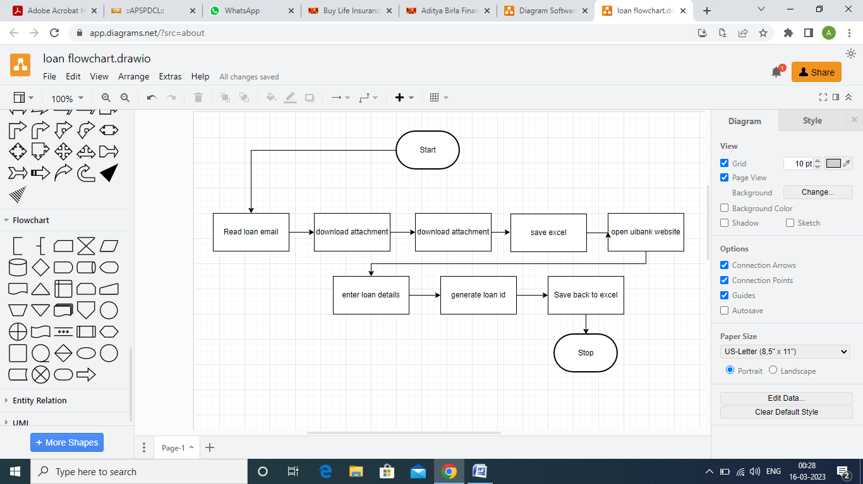

|  |  |
| --- | --- |
| **Slno** | Description |
| **1.1** | Read loan Email |
| **1.2** | Download the attachment |
| **1.3** | Save the excel file |
| **1.4** | Open uibank website |
| **1.5** | Enter loan details |
| **1.6** | Generate loan id |
| **1.7** | Save back to excel |

## Detailed Process Steps

|  |  |  |
| --- | --- | --- |
| Slno | **Step action**  **Description** | **Screenshot** |
| 1.1 | Read the email and download the attachment |  |
| 1.2 | Download the attachment |  |
| 1.3 | Open uibank loan application |  |
| 1.4 | Enter the load details |  |

## 

## Business Exceptions handling

All the business exceptions that are identified are classified below

|  |
| --- |
| **Exceptions** |
| * No Email * Email with no attachment * Age below 18 * Loan term should be 1 3 5 10 |

**Known exceptions**

The table below reflects all the exceptions that are encountered during the process evalution and documentation.

these are known exceptions**.** It also exhibits the actions that has to be taken during the exceptions occur

|  |  |  |
| --- | --- | --- |
| Slno | exception | Actions to be taken |
| 1 | Browser not responding | Restart the browser |
| 2 | Browser extension missing | Enable the extension |
| 3 | Email not received | Check with mail information provider team |

**Unknown exceptions**

For any other unanticipated or unknown exceptions, the robot should send error message

screenshot attached.